Enhancement of picture quality on ultra-low brightness by optimizing the electrical potential required for OLED charging in the AMOLED displays

Se Hwan Naa, Won Kyung Mina, Do Hyung Kimb, Han Wook Hwangb, Yong Min Hab, and Hyun Jae Kima*

a *School of Electrical and Electronic Engineering, Yonsei University, 50 Yonsei-ro, Seodaemun-gu, Seoul 03722, Republic of Korea*

b LG Display, Co., Ltd., Paju 10845, Republic of Korea

*Corresponding Author: Hyun Jae Kim

E-mail: hjk3@yonsei.ac.kr

**Se Hwan Na**

Tel.: +82-10-3464-8481

E-mail: luz1009@yonsei.ac.kr

**Hyun Jae Kim**

Tel.: +82-2-2123-5865

E-mail: hjk3@yonsei.ac.kr Supplement Information

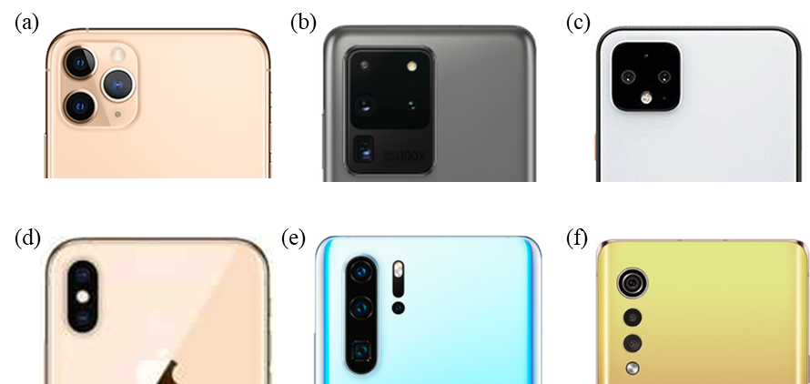

Figure S. An example image of the latest smartphone camera with wide-angle, high magnification (zoom), and low-light environments shooting performance. (a) iPhone11 Pro, (b) Galaxy S20, (c) Google Pixel 4, (d) iPhone XS, (e) Honor View20, (f) LG Velvet.

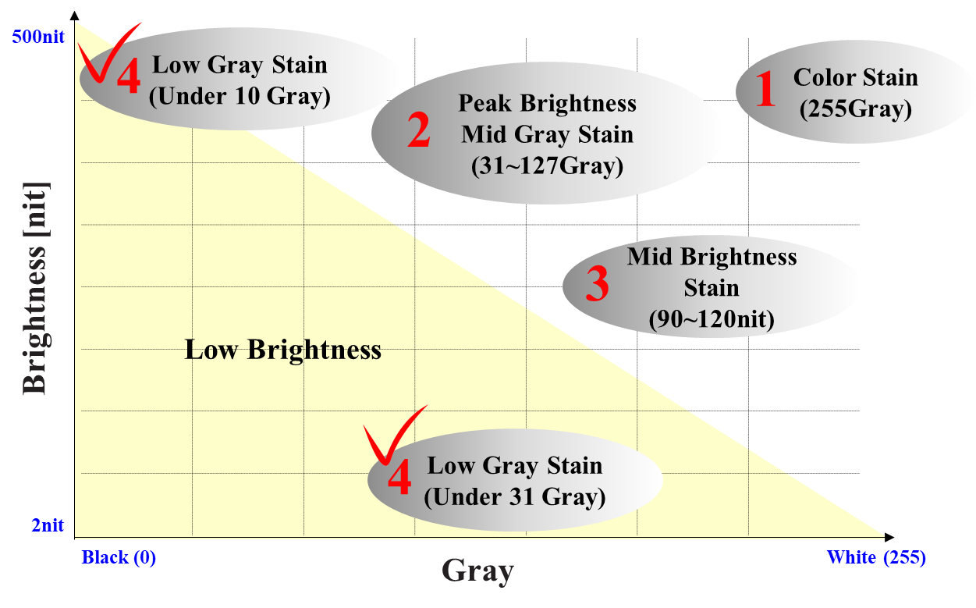

Figure S. Classification of stain (mura) according to luminance and gray level

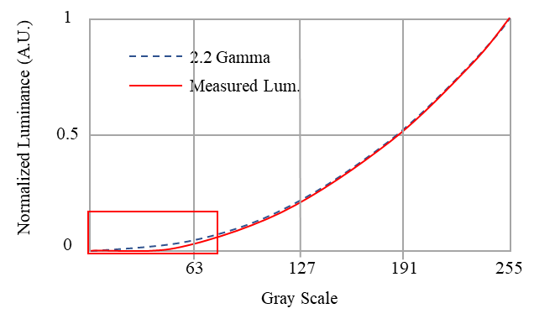

(a)

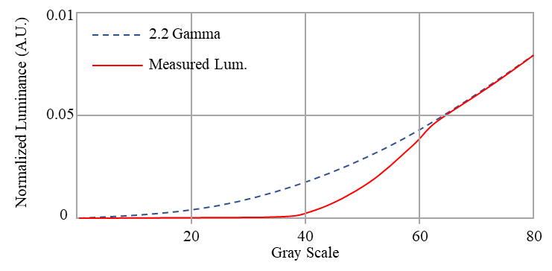

(b)

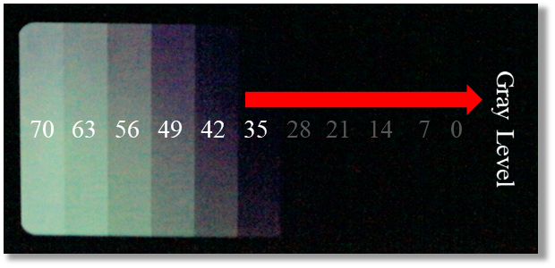

(c)

Figure S. Gamma crush at 2 nit mode in 5.99” QHD+ AMOLED panel (a) low gray gamma crush under 35 gray level, (b) gamma curve from 0 to 80 gray level in red box of (a), and (c) actual phenomenon of gamma crush from 0 to 80 gray level on the AMOLED panel. The panel does not emit under 35 gray level.

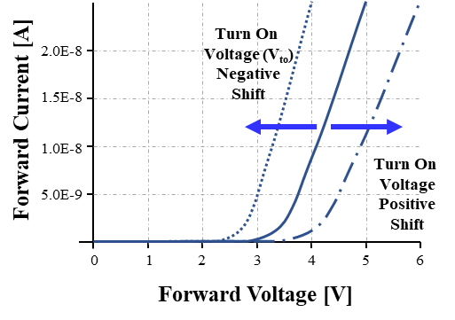

(a)

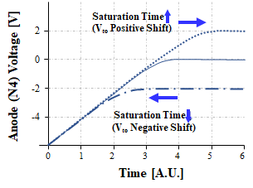

(b)

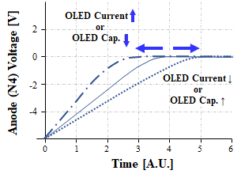

(c)

Figure S4. Saturation time changes by OLED characteristics (a) OLED turn on voltage positive and negative shift case, (b) Anode voltage transition by turn on voltage of OLED, and (c) Saturation time transition by OLED characteristics such as the current or capacitance of OLED etc.

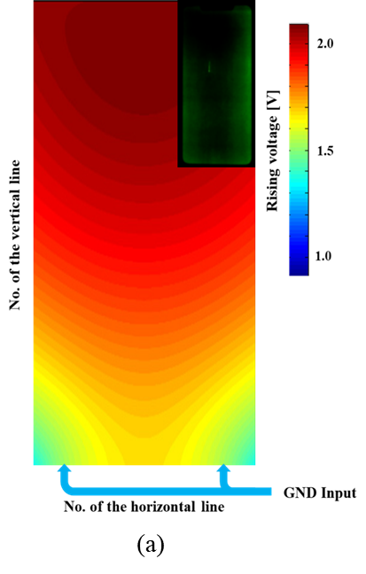 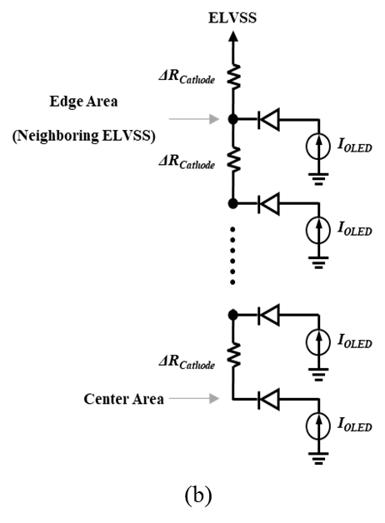

Figure S5. Comparison of simulation and stain phenomenon. (a) ELVSS rising simulation result of the 6.39” FHD+ AMOLED panel and stain phenomenon in the upper right box. (b) The electrical model of ELVSS IR rising. The resistance increased from bottom-edge to center, and panel luminance decreased with rising the resistance of the cathode.

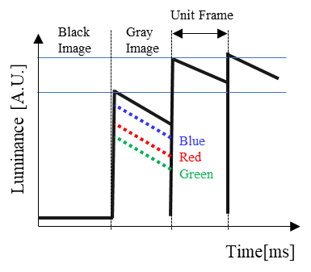

Figure S6. Black to White response characteristics schematic. The measured result was inscribed in Table 1.

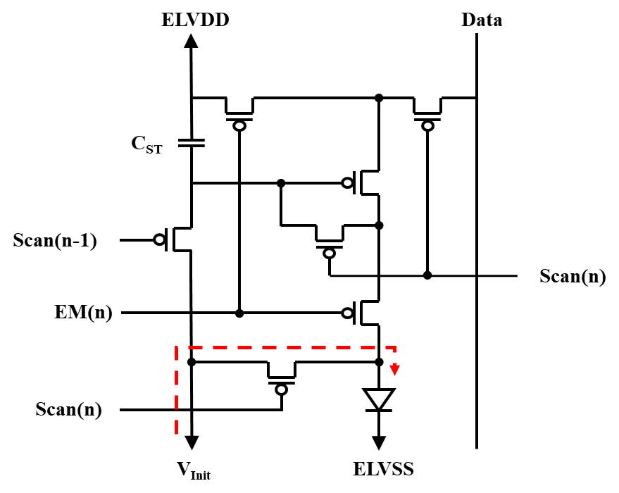

Figure S7. P-Type 7T1C compensation pixel circuit schematic.

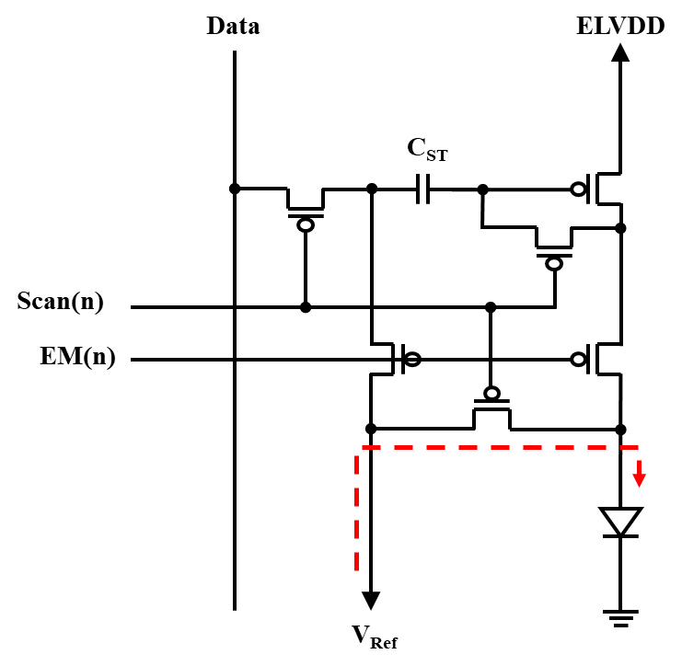

Figure S8. P-type 6T1C compensation pixel circuit schematic.

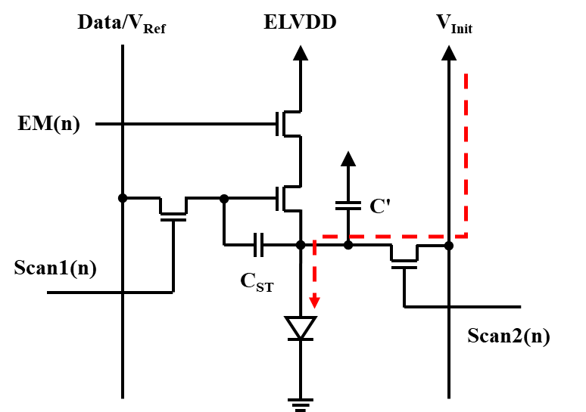

Figure S9. N-Type 4T2C compensation pixel circuit schematic.

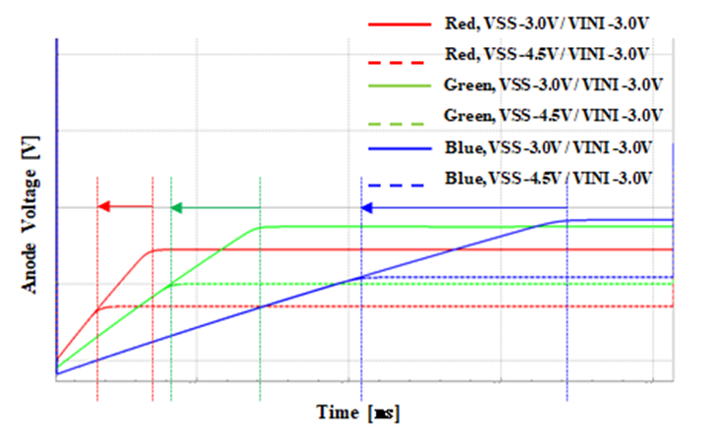

Figure S10. Simulation result of anode voltage according to changing the ELVSS. Lowering the ELVSS shows same result to rising the Vini. The Vsat depends on ELVSS because it is defined by OLED IV characteristics.

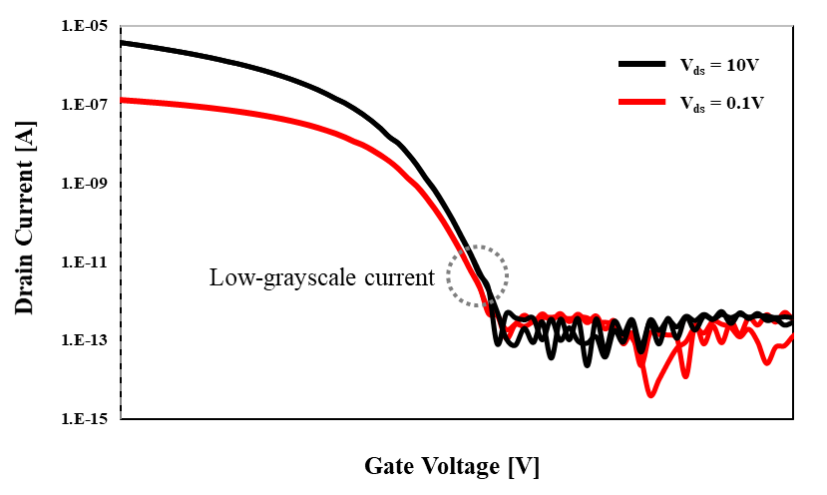

Fig. S11 Transfer characteristics of driving TFTs.